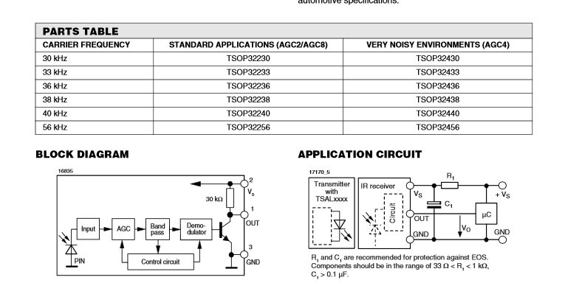

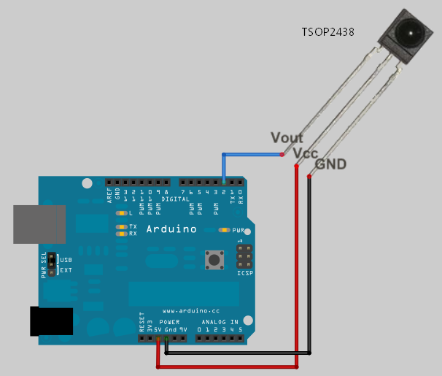
For Vishay IR receiver, 2.5-5V input,
0.10 uF | 104

R 33 – 1000 ohm

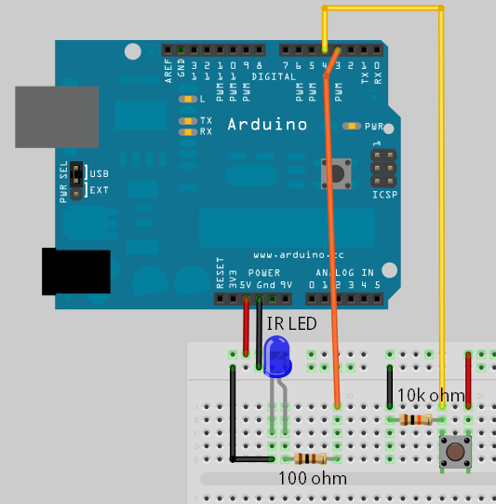

Bread board, 5 wire, the center one is not used (Vs) != Vcc 3.3V
All resiter are 100 ohm
DOUT, GND, NOT in use, DIN, Vcc(3.3V)

